Rational Numbers Set
# Source: AI Source: Provided by: [Data Path: Persons Table -> ID Column: 1, Name_En Column: Motasem Essam] -> From: [ChatGPT] on [7/15/2026]
The Rational Numbers Set is the set of all numbers that can be expressed as the quotient (fraction) of two integers, where the denominator is not zero. Rational numbers include integers, fractions, terminating decimals, and repeating decimals.
Rational numbers are fundamental to arithmetic, algebra, geometry, calculus, engineering, economics, computer science, and many real-world applications.

Definition
# Source: AI Source: Provided by: [Data Path: Persons Table -> ID Column: 1, Name_En Column: Motasem Essam] -> From: [ChatGPT] on [7/15/2026]
The Rational Numbers Set is the collection of all numbers that can be written in the form
$$\boxed{\frac{a}{b}}$$
where
- $a$and $b$are integers, and
- $b≠0$.
It is denoted by
$$\boxed{Q}$$
The symbol $Q$comes from the word Quotient.
The set is defined as
$$\boxed{Q=\left\{\frac{a}{b}:a,b∈Z, b≠0\right\}}$$

Set Notation
# Source: AI Source: Provided by: [Data Path: Persons Table -> ID Column: 1, Name_En Column: Motasem Essam] -> From: [ChatGPT] on [7/15/2026]
Set-Builder Notation
$$\boxed{Q=\left\{\frac{a}{b}:a,b∈Z, b≠0\right\}}$$
Description
The Rational Numbers Set contains every number that can be represented exactly as a fraction of two integers.

Examples
# Source: AI Source: Provided by: [Data Path: Persons Table -> ID Column: 1, Name_En Column: Motasem Essam] -> From: [ChatGPT] on [7/15/2026]
Examples of rational numbers include
$$-10, -3, 0, 4, \frac{1}{2}, -\frac{7}{5}, 2.75, 0.333…, 1.125$$

Decimal Representation
# Source: AI Source: Provided by: [Data Path: Persons Table -> ID Column: 1, Name_En Column: Motasem Essam] -> From: [ChatGPT] on [7/15/2026]
Every rational number has a decimal expansion that is either:
Terminating
Examples:
$$0.5, 0.25, 2.75, 7.125$$

Repeating (Recurring)
Examples:
$$0.333…, \\ 0.272727…, \\ 5.181818…$$
Every repeating decimal represents a rational number.

Non-Examples
# Source: AI Source: Provided by: [Data Path: Persons Table -> ID Column: 1, Name_En Column: Motasem Essam] -> From: [ChatGPT] on [7/15/2026]
The following are not rational numbers:
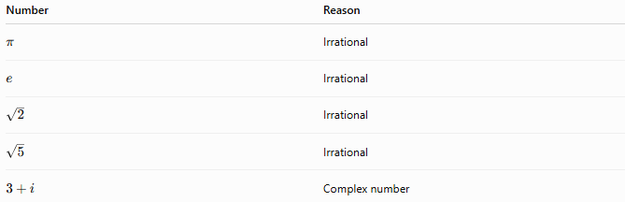
Number | Reason
$$π$$ | Irrational
$$e$$ | Irrational
$$\sqrt{2}$$ | Irrational
$$\sqrt{5}$$ | Irrational
$$3+i$$ | Complex number

Categories of Rational Numbers
# Source: AI Source: Provided by: [Data Path: Persons Table -> ID Column: 1, Name_En Column: Motasem Essam] -> From: [ChatGPT] on [7/15/2026]
The Rational Numbers Set includes:

Positive Integers
# Source: AI Source: Provided by: [Data Path: Persons Table -> ID Column: 1, Name_En Column: Motasem Essam] -> From: [ChatGPT] on [7/15/2026]
$$1, 2, 3,…$$

Negative Integers
# Source: AI Source: Provided by: [Data Path: Persons Table -> ID Column: 1, Name_En Column: Motasem Essam] -> From: [ChatGPT] on [7/15/2026]
$$-1, -2, -3,…$$

Zero
# Source: AI Source: Provided by: [Data Path: Persons Table -> ID Column: 1, Name_En Column: Motasem Essam] -> From: [ChatGPT] on [7/15/2026]
$$0$$

Positive Fractions
# Source: AI Source: Provided by: [Data Path: Persons Table -> ID Column: 1, Name_En Column: Motasem Essam] -> From: [ChatGPT] on [7/15/2026]
$$\frac{1}{2}, \frac{3}{4}, \frac{7}{5}$$

Negative Fractions
# Source: AI Source: Provided by: [Data Path: Persons Table -> ID Column: 1, Name_En Column: Motasem Essam] -> From: [ChatGPT] on [7/15/2026]
$$-\frac{2}{5}, -\frac{7}{9}$$

Terminating Decimals
# Source: AI Source: Provided by: [Data Path: Persons Table -> ID Column: 1, Name_En Column: Motasem Essam] -> From: [ChatGPT] on [7/15/2026]
$$0.2, 5.75, 12.125$$

Repeating Decimals
# Source: AI Source: Provided by: [Data Path: Persons Table -> ID Column: 1, Name_En Column: Motasem Essam] -> From: [ChatGPT] on [7/15/2026]
$$0.666…, 3.141414…$$

Characteristics
# Source: AI Source: Provided by: [Data Path: Persons Table -> ID Column: 1, Name_En Column: Motasem Essam] -> From: [ChatGPT] on [7/15/2026]
Rational numbers:
- Can be written as a fraction.
- May be positive, negative, or zero.
- Have terminating or repeating decimal expansions.
- Form an infinite set.
- Are dense: between any two rational numbers there is another rational number.
Example:
Between
$$1$$
and
$$2$$
lies
$$\frac{3}{2}=1.5.$$

Properties
# Source: AI Source: Provided by: [Data Path: Persons Table -> ID Column: 1, Name_En Column: Motasem Essam] -> From: [ChatGPT] on [7/15/2026]
Closure
Rational numbers are closed under:
Addition
$$\frac{1}{2}+\frac{3}{4}=\frac{5}{4}$$
Subtraction
$$\frac{3}{4}-\frac{1}{2}=\frac{1}{4}$$
Multiplication
$$\frac{2}{3}×\frac{3}{5}=\frac{2}{5}$$
Division
$$\frac{1}{2}÷\frac{3}{4}=\frac{2}{3}$$
provided the divisor is not zero.

Commutative Property
Addition
$$a+b=b+a$$
Multiplication
$$ab=ba$$

Associative Property
Addition
$$\left(a+b)+c=a+(b+c\right)$$
Multiplication
$$\left(ab)c=a(bc\right)$$

Distributive Property
$$a(b+c)=ab+ac$$

Relationship to Other Number Sets
# Source: AI Source: Provided by: [Data Path: Persons Table -> ID Column: 1, Name_En Column: Motasem Essam] -> From: [ChatGPT] on [7/15/2026]
$$\boxed{N⊂W⊂Z⊂Q⊂R⊂C}$$
Every rational number is also:
- a real number,
- and a complex number (with imaginary part equal to zero).

Examples
# Source: AI Source: Provided by: [Data Path: Persons Table -> ID Column: 1, Name_En Column: Motasem Essam] -> From: [ChatGPT] on [7/15/2026]
Example 1
Determine whether
$$\frac{4}{5}$$
is rational.
Yes.
It is already written as a fraction.

Example 2
Determine whether
$$7$$
is rational.
Yes.
$$7=\frac{7}{1}$$

Example 3
Determine whether
$$0.125$$
is rational.
Yes.
$$0.125=\frac{1}{8}$$

Example 4
Determine whether
$$0.777777…$$
is rational.
Yes.
It is a repeating decimal.
$$0.\overset{‾}{7}=\frac{7}{9}$$

Example 5
Determine whether
$$π$$
is rational.
No.
It cannot be expressed as a fraction of two integers.

Applications
# Source: AI Source: Provided by: [Data Path: Persons Table -> ID Column: 1, Name_En Column: Motasem Essam] -> From: [ChatGPT] on [7/15/2026]
Rational numbers are used in:
- Arithmetic
- Algebra
- Geometry
- Engineering
- Finance
- Statistics
- Computer Science
- Physics
- Economics
- Measurement

Real-Life Applications
# Source: AI Source: Provided by: [Data Path: Persons Table -> ID Column: 1, Name_En Column: Motasem Essam] -> From: [ChatGPT] on [7/15/2026]
Rational numbers are used for:
- Measurements
- Cooking recipes
- Financial calculations
- Currency
- Percentages
- Probability
- Construction
- Engineering design
- Scientific measurements
- Data analysis

Common Mistakes
# Source: AI Source: Provided by: [Data Path: Persons Table -> ID Column: 1, Name_En Column: Motasem Essam] -> From: [ChatGPT] on [7/15/2026]
- Thinking every decimal is irrational.
- Confusing repeating decimals with irrational numbers.
- Forgetting that every integer is rational.
- Assuming irrational numbers can be written as fractions.
- Using a denominator of zero.

Key Points
# Source: AI Source: Provided by: [Data Path: Persons Table -> ID Column: 1, Name_En Column: Motasem Essam] -> From: [ChatGPT] on [7/15/2026]
- Rational numbers are numbers expressible as fractions.
- Every integer is rational.
- Every terminating decimal is rational.
- Every repeating decimal is rational.
- Rational numbers are dense on the number line.

Rational Numbers vs. Integers
# Source: AI Source: Provided by: [Data Path: Persons Table -> ID Column: 1, Name_En Column: Motasem Essam] -> From: [ChatGPT] on [7/15/2026]
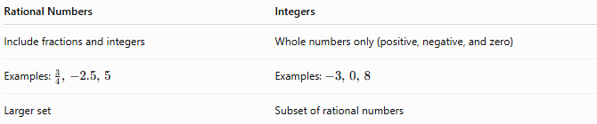
Rational Numbers | Integers
Include fractions and integers | Whole numbers only (positive, negative, and zero)
Examples: $\frac{3}{4}, -2.5, 5$ | Examples: $-3, 0, 8$
Larger set | Subset of rational numbers

Rational Numbers vs. Irrational Numbers
# Source: AI Source: Provided by: [Data Path: Persons Table -> ID Column: 1, Name_En Column: Motasem Essam] -> From: [ChatGPT] on [7/15/2026]
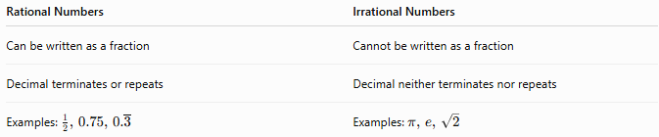
Rational Numbers | Irrational Numbers
Can be written as a fraction | Cannot be written as a fraction
Decimal terminates or repeats | Decimal neither terminates nor repeats
Examples: $\frac{1}{2}, 0.75, 0.\overset{‾}{3}$ | Examples: $π, e, \sqrt{2}$

Rational Numbers vs. Real Numbers
# Source: AI Source: Provided by: [Data Path: Persons Table -> ID Column: 1, Name_En Column: Motasem Essam] -> From: [ChatGPT] on [7/15/2026]
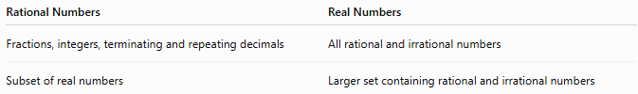
Rational Numbers | Real Numbers
Fractions, integers, terminating and repeating decimals | All rational and irrational numbers
Subset of real numbers | Larger set containing rational and irrational numbers

Conclusion
# Source: AI Source: Provided by: [Data Path: Persons Table -> ID Column: 1, Name_En Column: Motasem Essam] -> From: [ChatGPT] on [7/15/2026]
The Rational Numbers Set, denoted by $Q$, is the set of all numbers that can be written as the quotient of two integers with a nonzero denominator:
$$Q=\left\{\frac{a}{b}:a,b∈Z, b≠0\right\}.$$
It includes integers, fractions, terminating decimals, and repeating decimals. Rational numbers are infinite, dense on the number line, and closed under addition, subtraction, multiplication, and division (except by zero). They form one of the most important number sets in mathematics and are essential for calculations, measurement, finance, science, engineering, and everyday problem solving.

